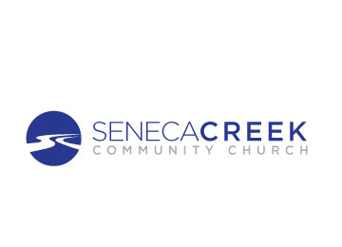

ESOL Program Manager

Position Description

**POSITION OVERVIEW**

The ESOL Program Manager will oversee the program of ESOL at SCCC, managing the staff and volunteers to accomplish the organization goals in alignment with the church’s vision and values. The Program Manager will collaborate with the General Manager, the Grant Manager, and other staff and volunteers in the church to increase ministry capacity and funding.

**KEY RESPONSIBILITIES**

* Ensure the ESOL Program has sufficient staff (paid and volunteers) to provide a quality program for adult learners, including recruiting, interviewing, onboarding, supervising, and supporting all staff – both paid and volunteer.
* Collaborate with the communications manager and appropriate staff to effectively advertise and promote class registration.
* Inspire and equip staff (paid and volunteer) to foster community and connections with student learners including inviting them to participate in other church and community resources and events.
* Ensure the program has appropriate levels of adult learners by overseeing registration, class schedules, size and location.
* Ensure the program meets all Grant requirements and produce periodic reports as required by funders and by collaborating with the Grant Manager to ensure all reporting requirements are met.
* Establish and oversee implementation of an effective student evaluation method, including class placement testing and final evaluations.
* Oversee and ensure accurate and confidential record keeping of all student information including attendance and test scores.
* Conduct annual training of all staff and volunteers and ensure that MCAEL classes are attended.
* Attend monthly staff meetings and regular 1:1 check-ins with the Hope Center General Manager.
* Ensure compliance with the established key performance indicators and regularly report to the Advisory Board

**QUALIFICATIONS AND SKILL**

* Ability to affirm and support the mission, vision and values of Seneca Creek Community Church
* Demonstrated success in managing paid and/or volunteer staff.
* Self-starter and organized
* Demonstrated leadership and management capacity
* Strong people skills, including the active listening and managing conflict when necessary
* Demonstrated cultural competence and the ability to effectively interact, work and develop meaningful relationships with people of various cultural backgrounds
* Ability to strategize, problem-solve, and develop effective systems for scale and growth
* Proficient computer skills, including Microsoft Word and Excel.
* Flexible and resilient in the face of constraints, frustration, or disappointment.
* ESOL and/or general teaching experience is desirable
* Bilingual Speaker is desirable but not required.

**Salary:** $25,000- $30,000 (regular, part-time, exempt)

**Hours:**

Combination of remote and on-site hours up to 20 hours per week

Must be on-site when Saturday classes are in session

Occasionally on site when weekday classes are in session